Dis-Eur-Czech Republic-Moravia-**Dolni Vestonice-25-29 kyBP**

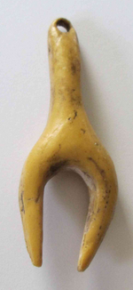 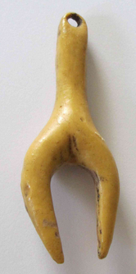

**Dolni Vestonice , South Moravia, the Czech Republic, Europe** **,   25,000 - 29,000 years old .**

Resin copy of the original carved of mammoth tusk.